Software Design Process – Software Engineering
Read
Courses

The design phase of software development deals with transforming the customer requirements as described in the SRS documents into a form implementable using a programming language. The software design process can be divided into the following three levels or phases of design:
- Interface Design
- Architectural Design
- Detailed Design

Elements of a System
- Architecture: This is the conceptual model that defines the structure, behavior, and views of a system. We can use flowcharts to represent and illustrate the architecture.
- Modules: These are components that handle one specific task in a system. A combination of the modules makes up the system.
- Components: This provides a particular function or group of related functions. They are made up of modules.
- Interfaces: This is the shared boundary across which the components of a system exchange information and relate.
- Data: This is the management of the information and data flow.
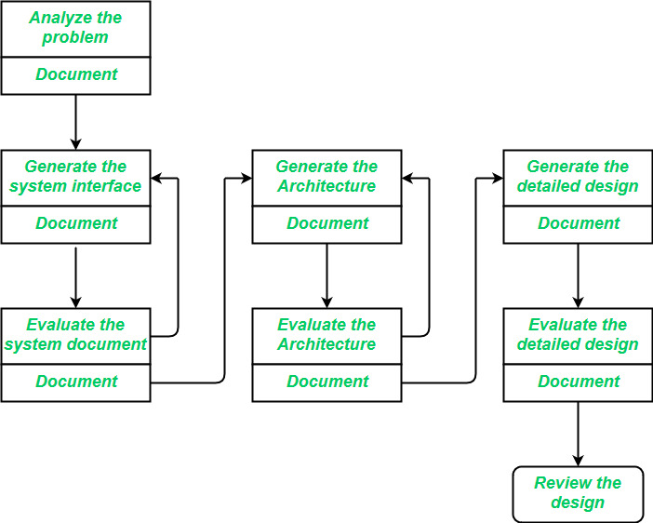
Software Design Process

Interface Design
Interface design is the specification of the interaction between a system and its environment. This phase proceeds at a high level of abstraction with respect to the inner workings of the system i.e, during interface design, the internal of the systems are completely ignored, and the system is treated as a black box. Attention is focused on the dialogue between the target system and the users, devices, and other systems with which it interacts. The design problem statement produced during the problem analysis step should identify the people, other systems, and devices which are collectively called agents.
Interface design should include the following details:
- Precise description of events in the environment, or messages from agents to which the system must respond.
- Precise description of the events or messages that the system must produce.
- Specification of the data, and the formats of the data coming into and going out of the system.
- Specification of the ordering and timing relationships between incoming events or messages, and outgoing events or outputs.

Architectural Design
Architectural design is the specification of the major components of a system, their responsibilities, properties, interfaces, and the relationships and interactions between them. In architectural design, the overall structure of the system is chosen, but the internal details of major components are ignored. Issues in architectural design includes:
- Gross decomposition of the systems into major components.
- Allocation of functional responsibilities to components.
- Component Interfaces.
- Component scaling and performance properties, resource consumption properties, reliability properties, and so forth.
- Communication and interaction between components.
The architectural design adds important details ignored during the interface design. Design of the internals of the major components is ignored until the last phase of the design.

Detailed Design
Design is the specification of the internal elements of all major system components, their properties, relationships, processing, and often their algorithms and the data structures. The detailed design may include:
- Decomposition of major system components into program units.
- Allocation of functional responsibilities to units.
- User interfaces.
- Unit states and state changes.
- Data and control interaction between units.
- Data packaging and implementation, including issues of scope and visibility of program elements.
- Algorithms and data structures.
Software Design is the process of transforming user requirements into a suitable form, which helps the programmer in software coding and implementation. During the software design phase, the design document is produced, based on the customer requirements as documented in the SRS document. Hence, this phase aims to transform the SRS document into a design document.
The following items are designed and documented during the design phase:
- Different modules are required.
- Control relationships among modules.
- Interface among different modules.
- Data structure among the different modules.
- Algorithms are required to be implemented among the individual modules.

Objectives of Software Design:
- Correctness:
A good design should be correct i.e., it should correctly implement all the functionalities of the system.
- Efficiency:
A good software design should address the resources, time, and cost optimization issues.
- Flexibility:
A good software design should have the ability to adapt and accommodate changes easily. It includes designing the software in a way, that allows for modifications, enhancements, and scalability without requiring significant rework or causing major disruptions to the existing functionality.
- Understandability:
A good design should be easily understandable, it should be modular, and all the modules are arranged in layers.
- Completeness:
The design should have all the components like data structures, modules, and external interfaces, etc.
- Maintainability:
A good software design aims to create a system that is easy to understand, modify, and maintain over time. This involves using modular and well-structured design principles e.g.,(employing appropriate naming conventions and providing clear documentation). Maintainability in software Design also enables developers to fix bugs, enhance features, and adapt the software to changing requirements without excessive effort or introducing new issues.

Software Design Concepts:
Concepts are defined as a principal idea or invention that comes into our mind or in thought to understand something. The software design concept simply means the idea or principle behind the design. It describes how you plan to solve the problem of designing software, the logic, or thinking behind how you will design software. It allows the software engineer to create the model of the system or software or product that is to be developed or built. The software design concept provides a supporting and essential structure or model for developing the right software. There are many concepts of software design and some of them are given below:
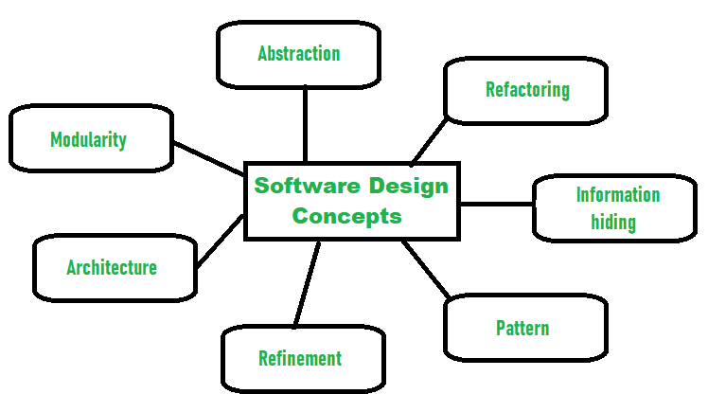
Software Design process

Points should be considered while Designing Software:
- Abstraction- (Hide Irrelevant data )
Abstraction simply means to hide the details to reduce complexity and increases efficiency or quality. Different levels of Abstraction are necessary and must be applied at each stage of the design process so that any error that is present can be removed to increase the efficiency of the software solution and to refine the software solution. The solution should be described in broad ways that cover a wide range of different things at a higher level of abstraction and a more detailed description of a solution of software should be given at the lower level of abstraction.
- Modularity- (subdivide the system)
Modularity simply means dividing the system or project into smaller parts to reduce the complexity of the system or project. In the same way, modularity in design means subdividing a system into smaller parts so that these parts can be created independently and then use these parts in different systems to perform different functions. It is necessary to divide the software into components known as modules because nowadays, there are different software available like Monolithic software that is hard to grasp for software engineers. So, modularity in design has now become a trend and is also important. If the system contains fewer components then it would mean the system is complex which requires a lot of effort (cost) but if we are able to divide the system into components then the cost would be small.
- Architecture- (design a structure of something )
Architecture simply means a technique to design a structure of something. Architecture in designing software is a concept that focuses on various elements and the data of the structure. These components interact with each other and use the data of the structure in architecture.
- Refinement- (removes impurities)
Refinement simply means to refine something to remove any impurities if present and increase the quality. The refinement concept of software design is actually a process of developing or presenting the software or system in a detailed manner that means to elaborate a system or software. Refinement is very necessary to find out any error if present and then to reduce it.
- Pattern- (a Repeated form)
The pattern simply means a repeated form or design in which the same shape is repeated several times to form a pattern. The pattern in the design process means the repetition of a solution to a common recurring problem within a certain context.
- Information Hiding – Hide the Information
Information hiding simply means to hide the information so that it cannot be accessed by an unwanted party. In software design, information hiding is achieved by designing the modules in a manner that the information gathered or contained in one module is hidden and can’t be accessed by any other modules.
- Refactoring-( Reconstruct something )
Refactoring simply means reconstructing something in such a way that it does not affect the behavior of any other features. Refactoring in software design means reconstructing the design to reduce complexity and simplify it without impacting the behavior or its functions. Fowler has defined refactoring as “the process of changing a software system in a way that it won’t impact the behavior of the design and improves the internal structure”.

Different levels of Software Design:
There are three different levels of software design. They are:
- Architectural Design:
The architecture of a system can be viewed as the overall structure of the system & the way in which structure provides conceptual integrity of the system. The architectural design identifies the software as a system with many components interacting with each other. At this level, the designers get the idea of the proposed solution domain.
- Preliminary or high-level design:
Here the problem is decomposed into a set of modules, the control relationship among various modules identified, and also the interfaces among various modules are identified. The outcome of this stage is called the program architecture. Design representation techniques used in this stage are structure chart and UML.
- Detailed design:
Once the high-level design is complete, a detailed design is undertaken. In detailed design, each module is examined carefully to design the data structure and algorithms. The stage outcome is documented in the form of a module specification document.

